|  |  |  |  |  |  |
| --- | --- | --- | --- | --- | --- |
| Date | 7-Dec-22 | | | Tester Name | Mohammad Yusuf |
| Environment | Penfax - Test | | | Login used |  |
| Operating System | Select OS | Version: | Update: | | |
| Software Used | Select Software | Version: | Update: | | |
| Select Software | Version: | Update: | | |
| Release version |  | | | | |
| Title | M17 Contributions & DCT | | | | |
| Test Type | Regression | | | | |
| Test Scenario | M17.25 Edit File Headers on a Contribution File | | | | |
|  |  | | | | |
| Expected Results | Pay Cycle and Pay Period should be editable and saved. | | | | |
| Pass/Fail | Pass | | | JIRA# | N/A |

Describe your steps with screenshots:

1. Log into MEPP DCT and select the Employer from the dropdown.

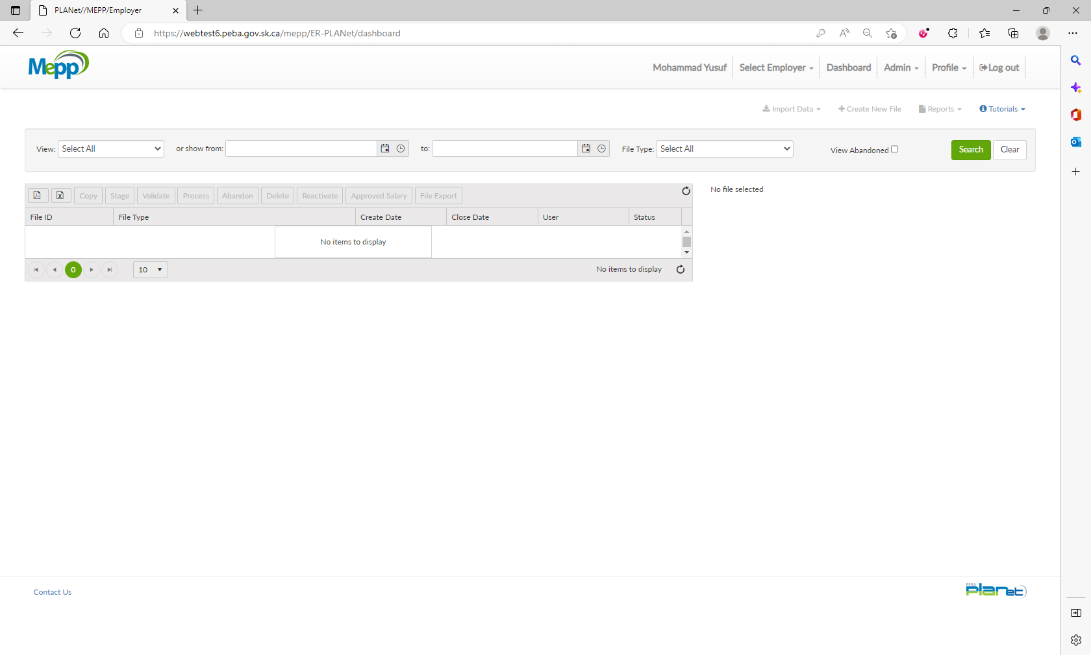

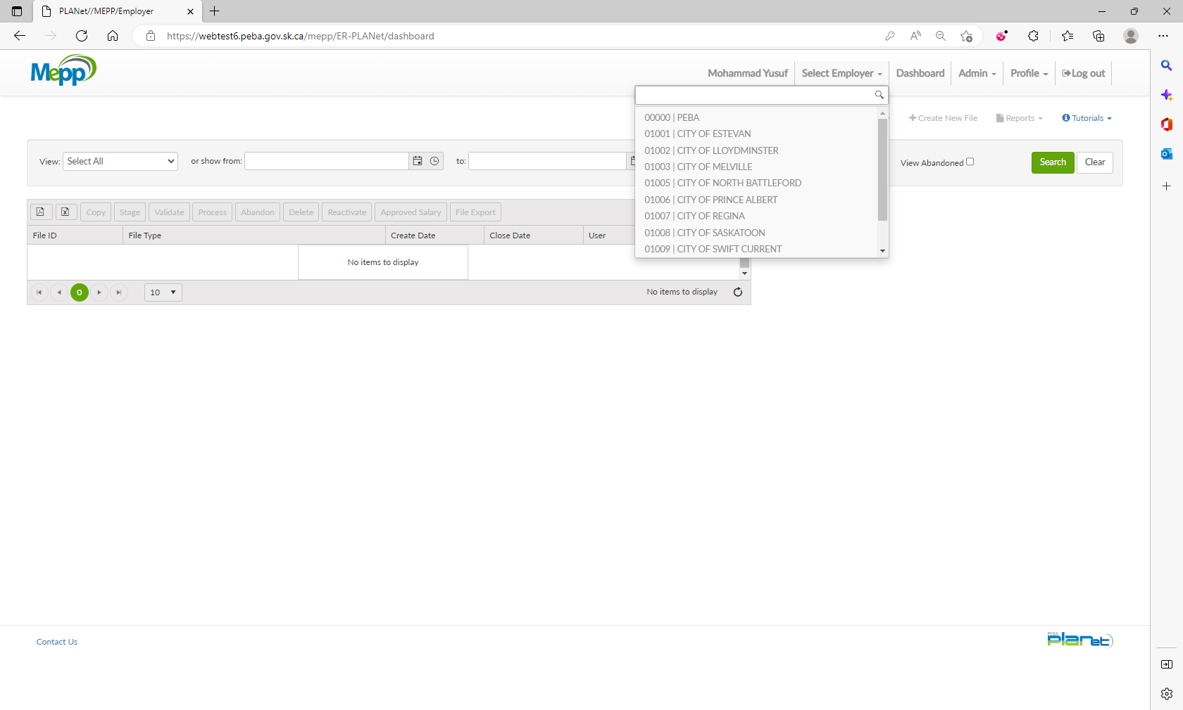

1. Click on Create New File.

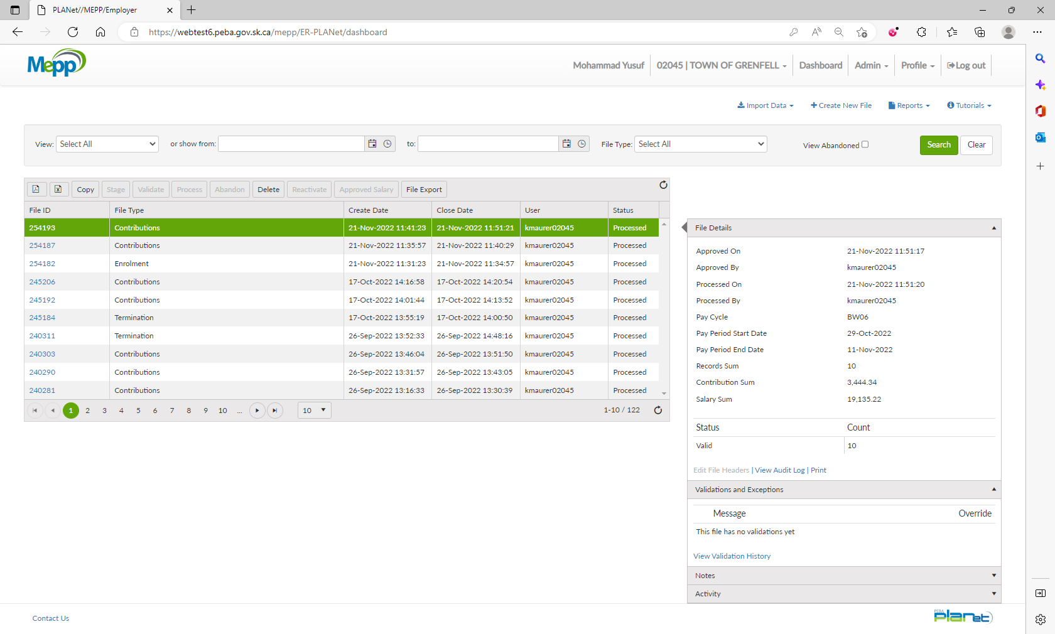

1. Select Contribution from the dropdown.

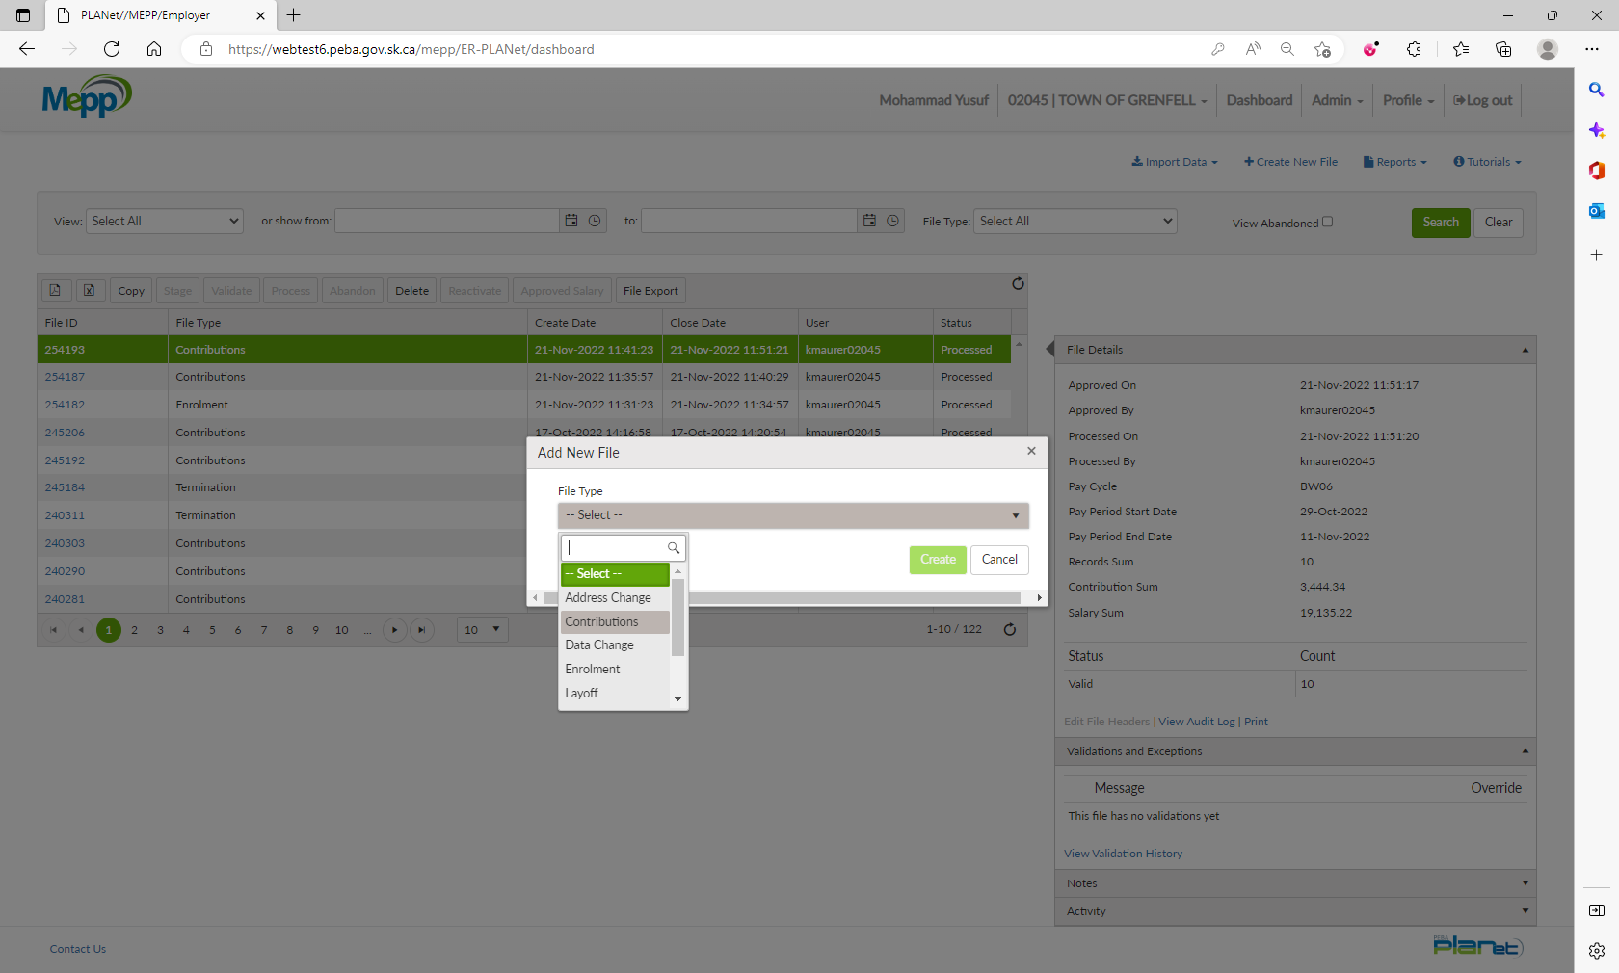

1. Input Pay Cycle and Pay Period and click on Create.

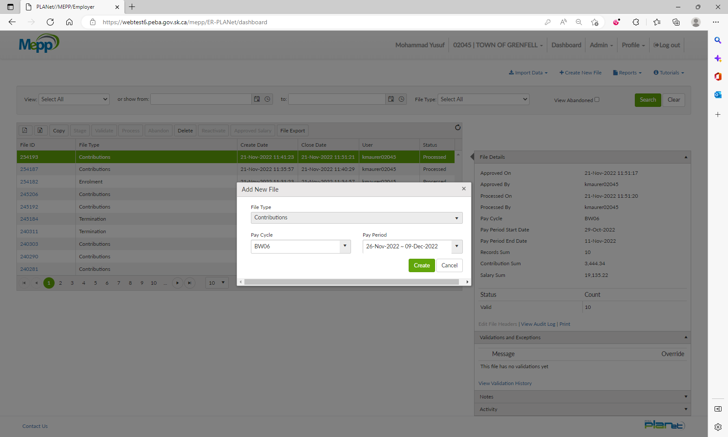

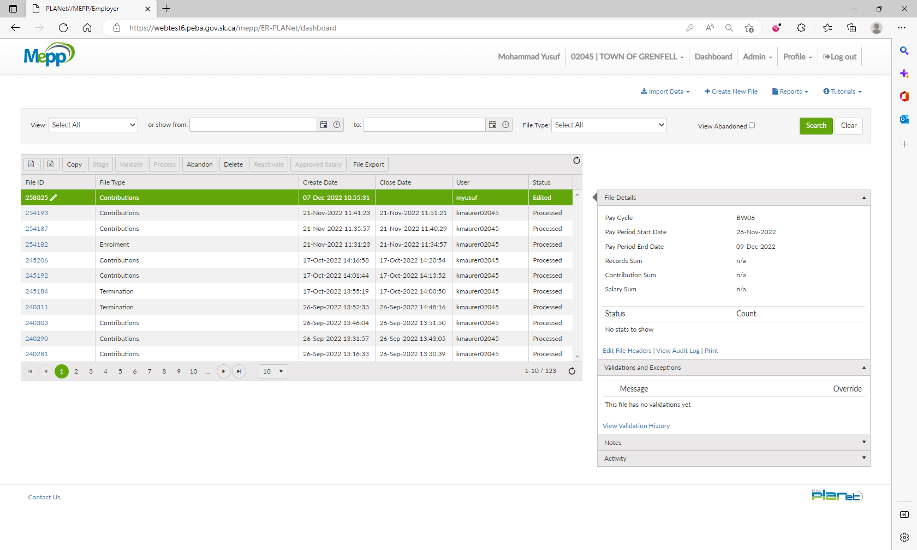

1. Click on File ID.

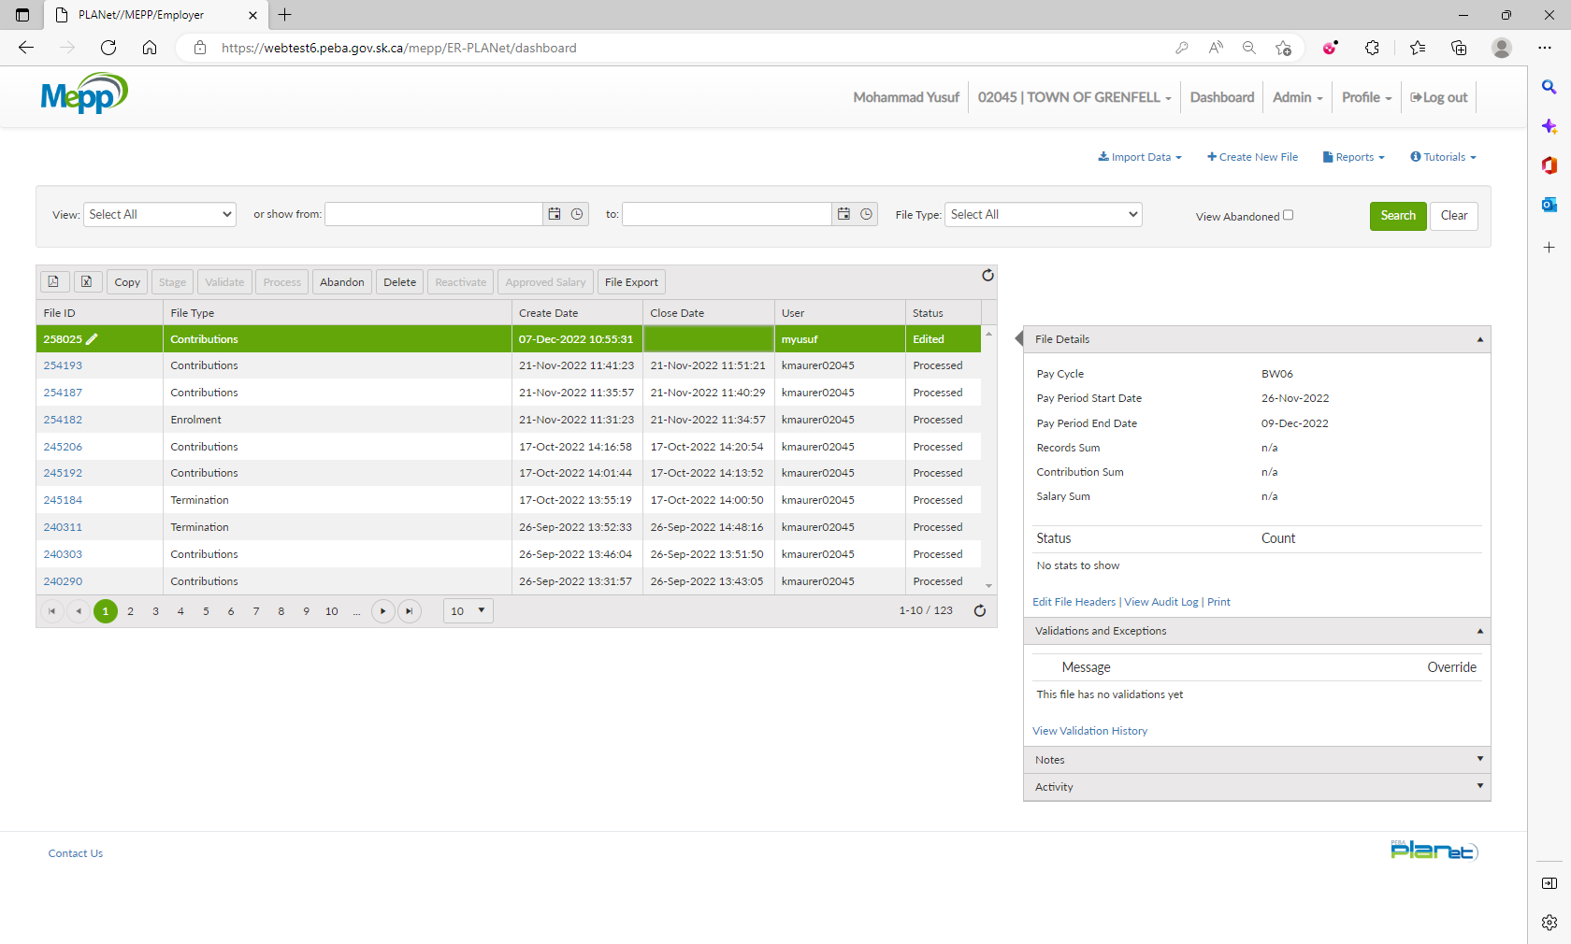

1. Click on Add to add the transactions.

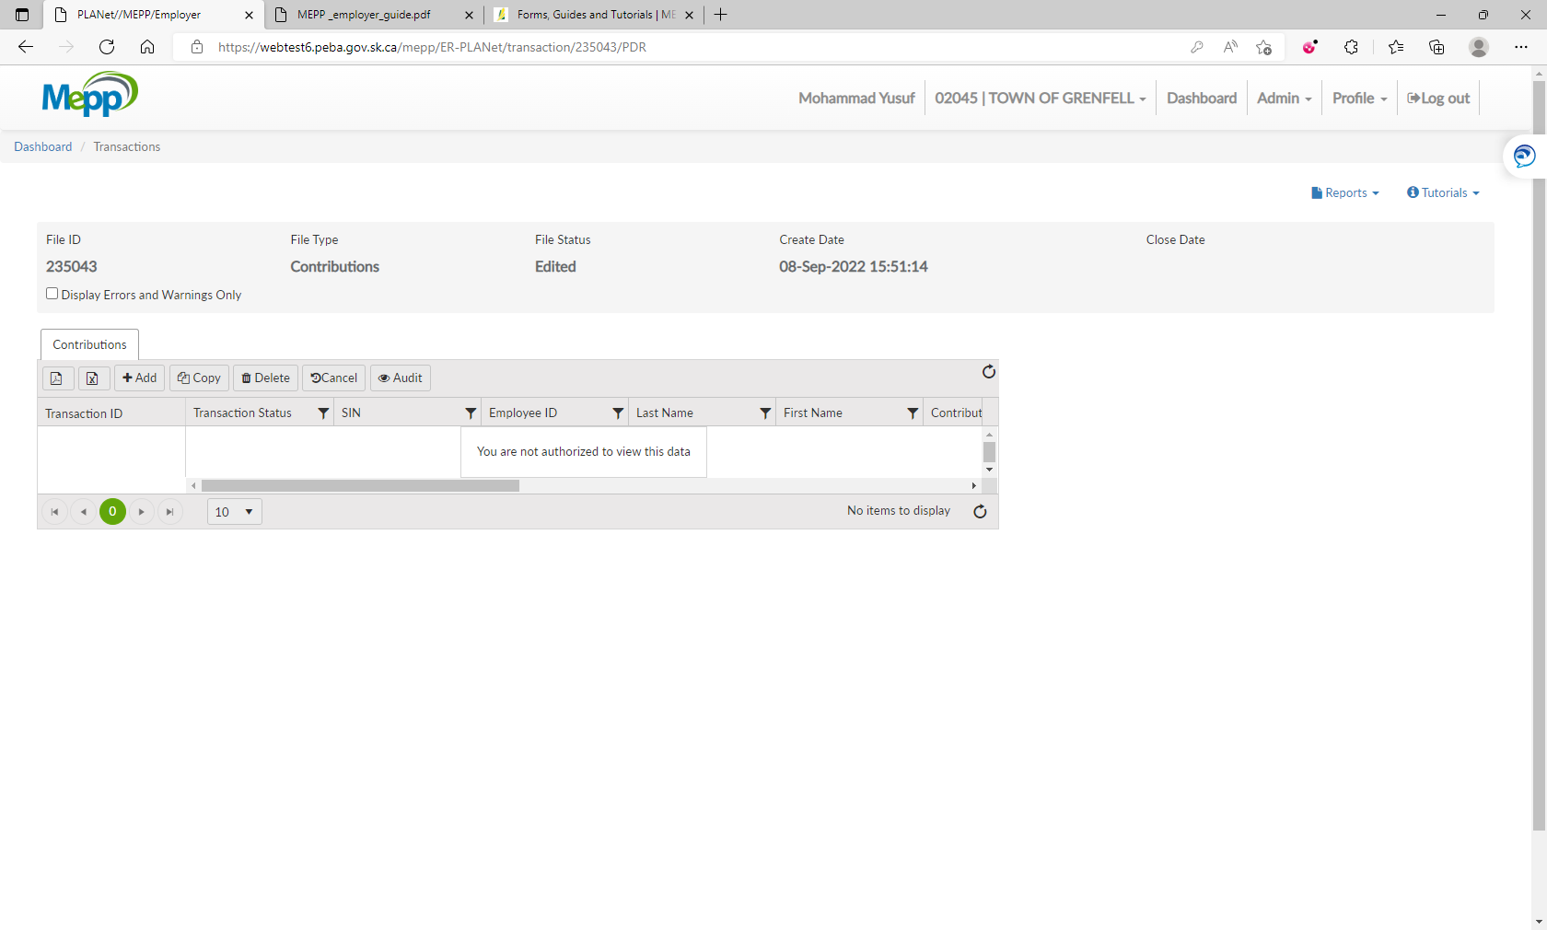

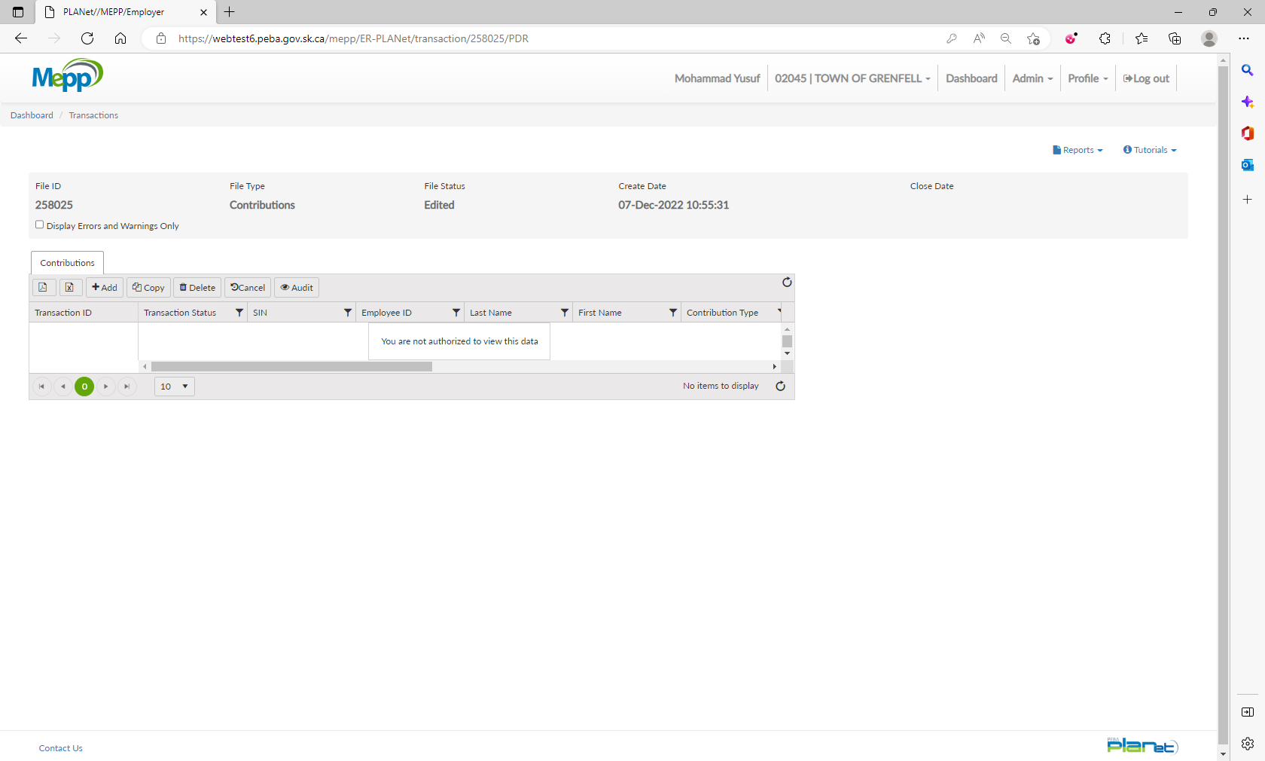

1. Input all the required details and Save.

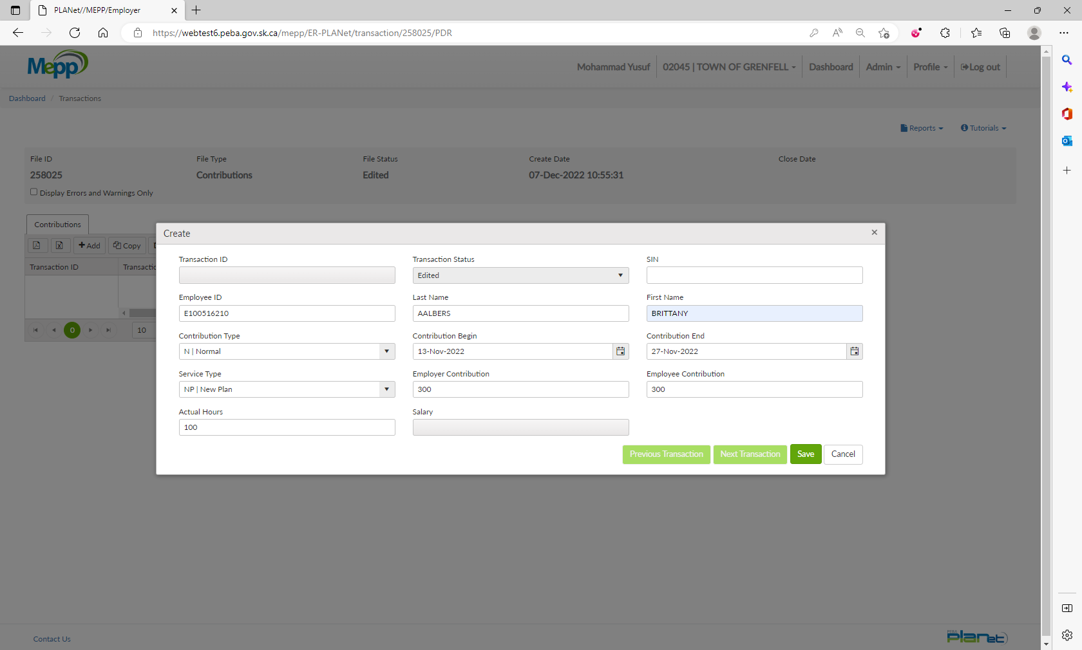

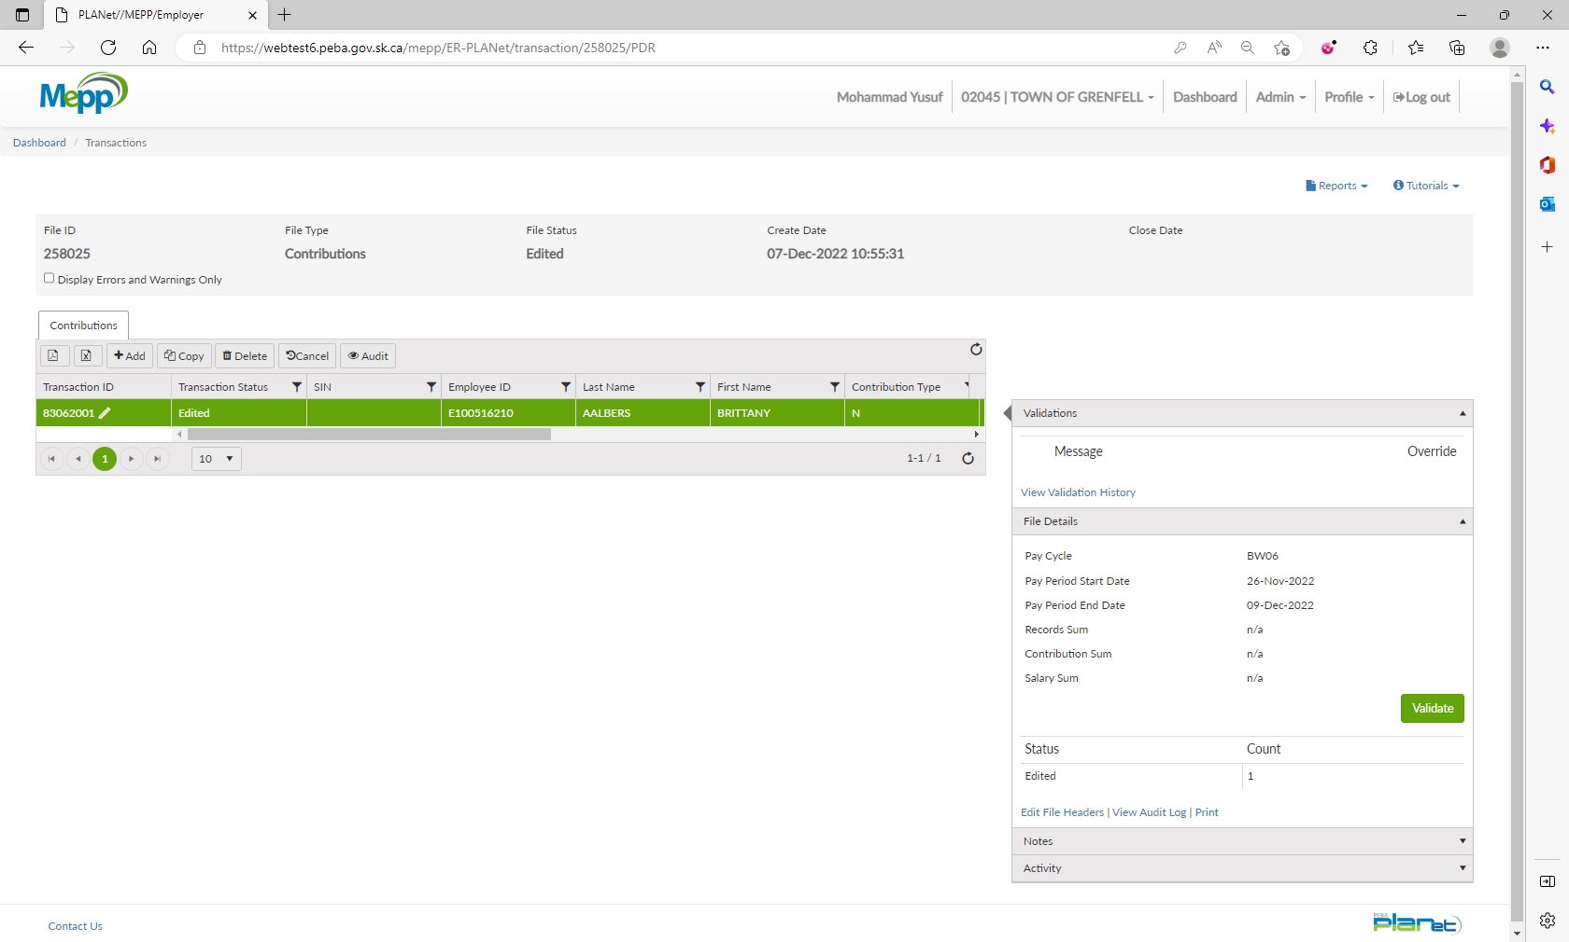

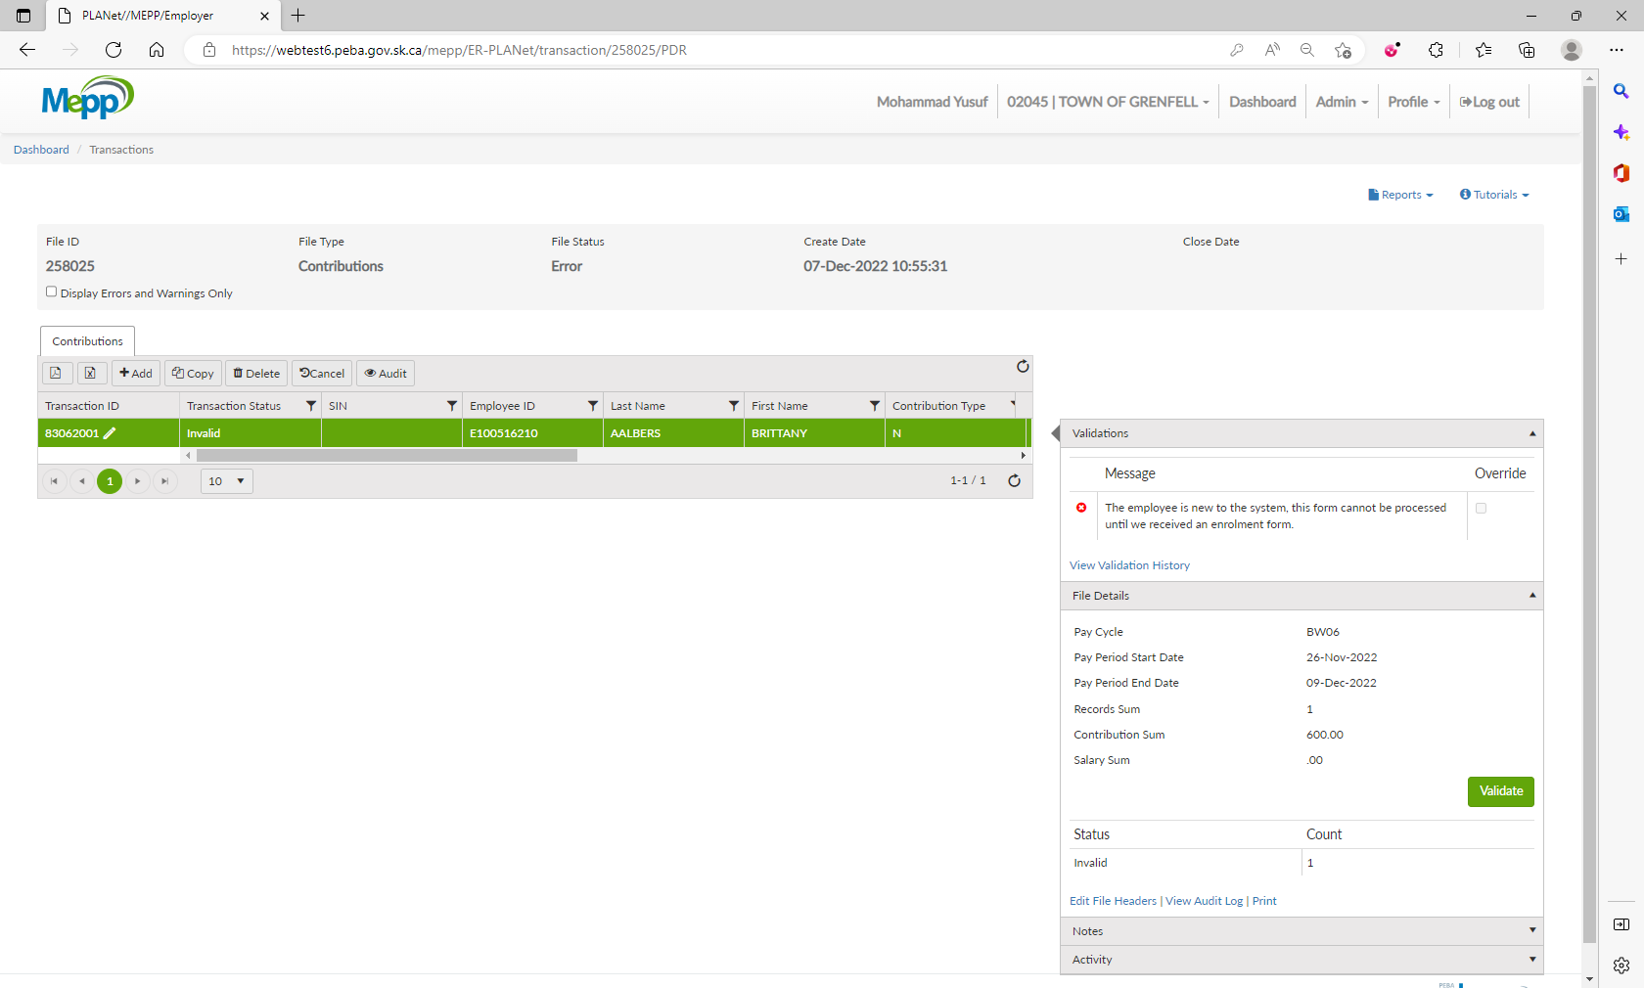

Click on Edit File Headers

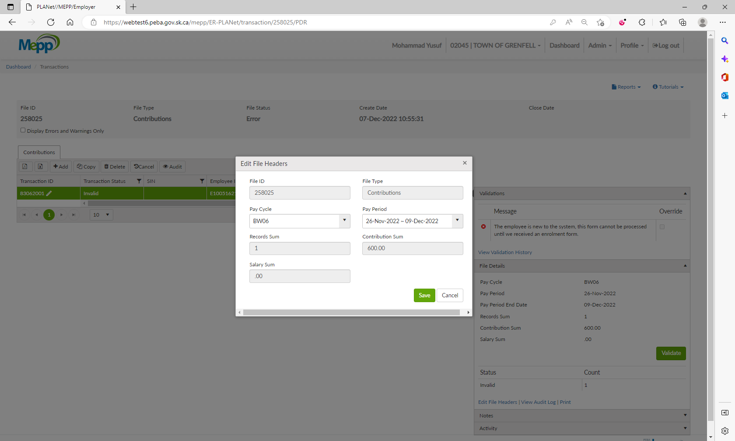

User is able to modify the Header on Contribution File

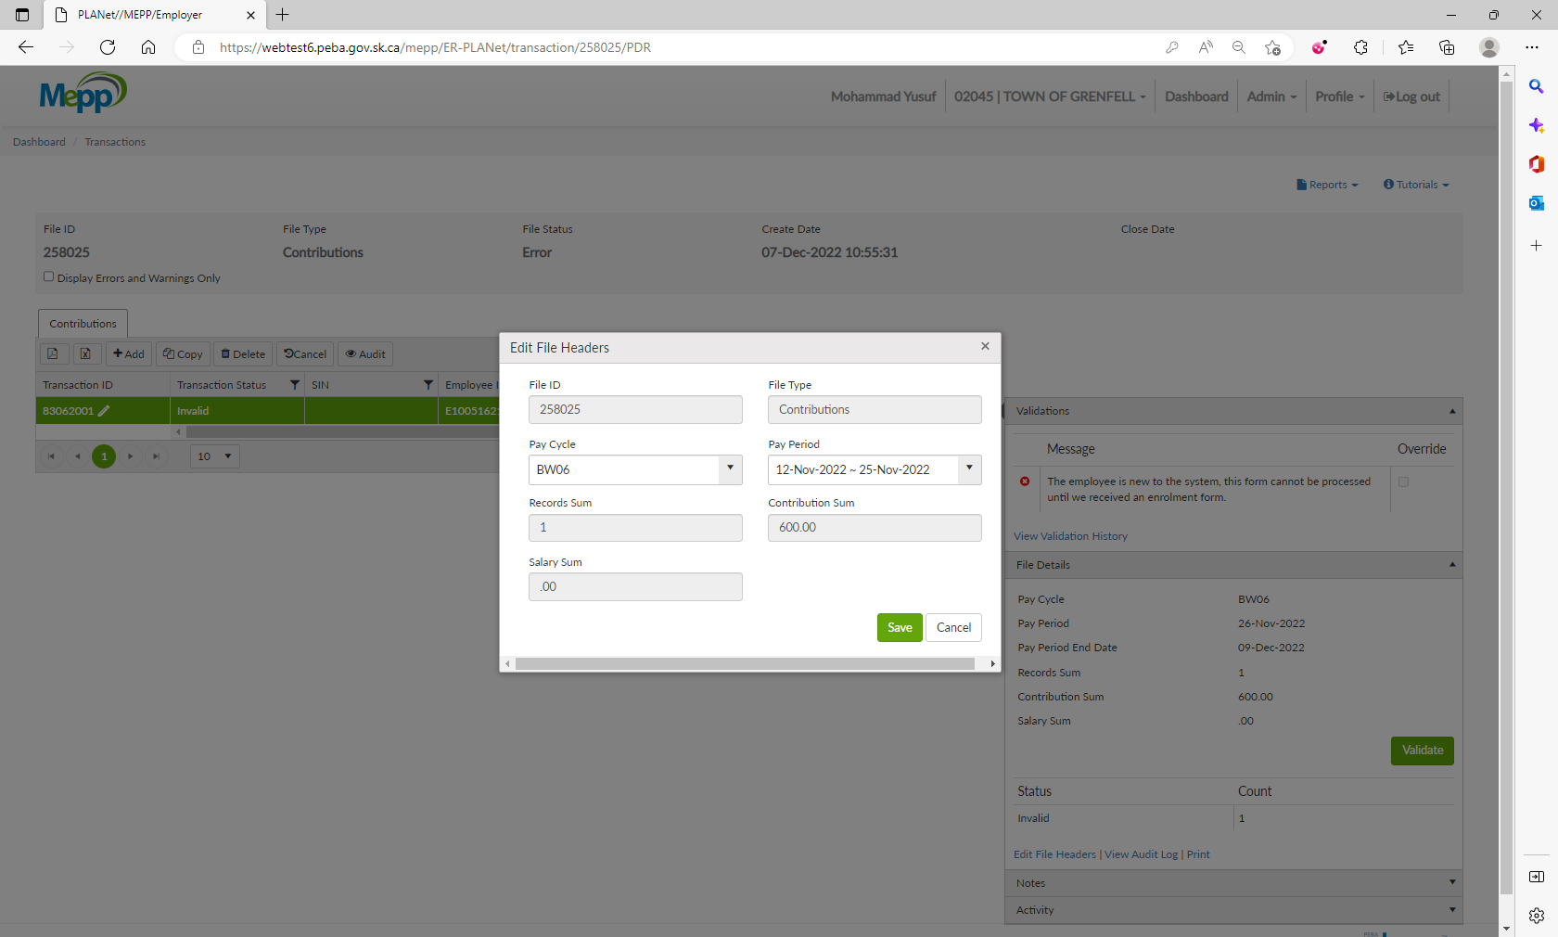

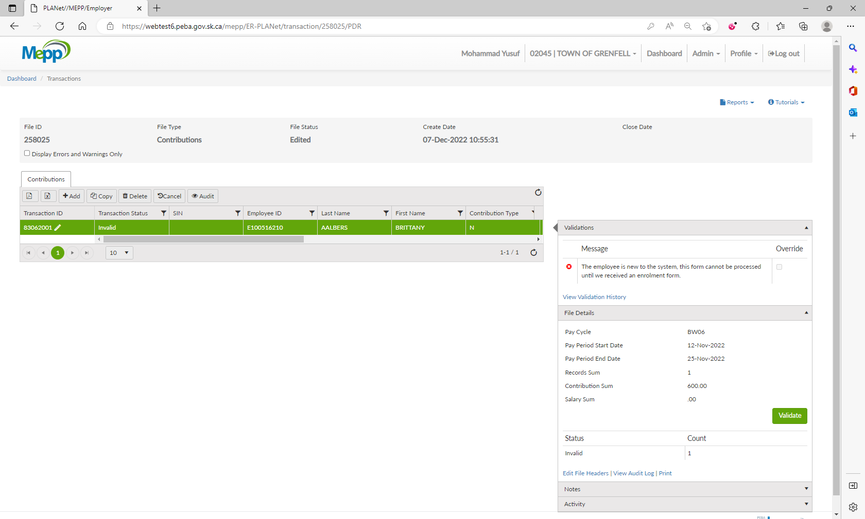

After correcting the other error, the contribution file can be processed